Ops Portal Overview - Dashboard

The Dashboard is the homepage of the new Ops Portal. After a banner and store are selected the first time, the site will remember this choice. The content on the new site will be filtered by store, so if you see information on the site, it impacts your store.

|  |  |
| --- | --- |
|  | 1. Top-Level Menu    1. Urgent Notices (optional)    2. Dashboard    3. Calendar    4. Communications    5. Alerts    6. Library 2. Active Banner    1. Sport Chek or Atmosphere 3. Active store and Store Select List    1. triggers banner/store selection 4. Featured Content section 5. Feature tile 6. Quick Links area 7. Latest Communications    1. quickly access recently added communications 8. Notifications    1. quickly access recently added documents 9. Global Search 10. Updates/Feedback     1. What’s New - release notes     2. Report a Bug - user comment form |

Ops Portal Overview - Urgent Notices

The Urgent Notices area of the Ops Portal is only accessible when there are active Urgent Notices. Click on the Urgent Notices tab to see any active Urgent Notices. Click on a listed Urgent Notice for details and/or relevant attachments.

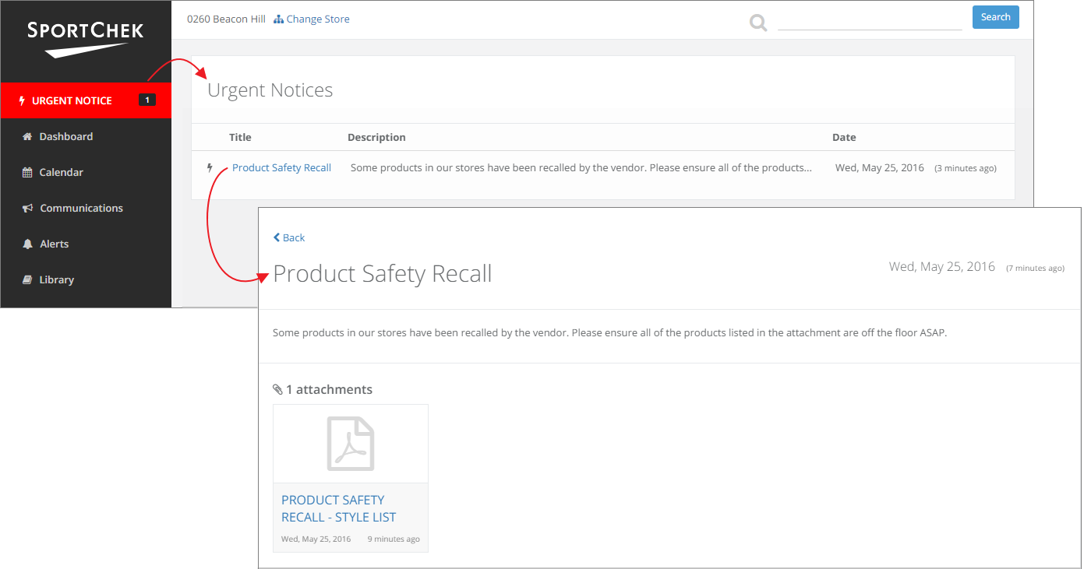

Ops Portal Overview - Workload Calendar

|  |  |
| --- | --- |
| The Calendar feature replaces the PDF Workload Calendar. You can see upcoming events, product launches and tasks in an easy-to-read and browse calendar format.  Click on an event to see details. |  |

Ops Portal Overview - Communications Listing

The Communications feature houses email-like messages (with attachments) that cannot be accidentally deleted from a store’s Outlook inbox. You can also access archived communications by clicking on the **Show Archive** toggle.

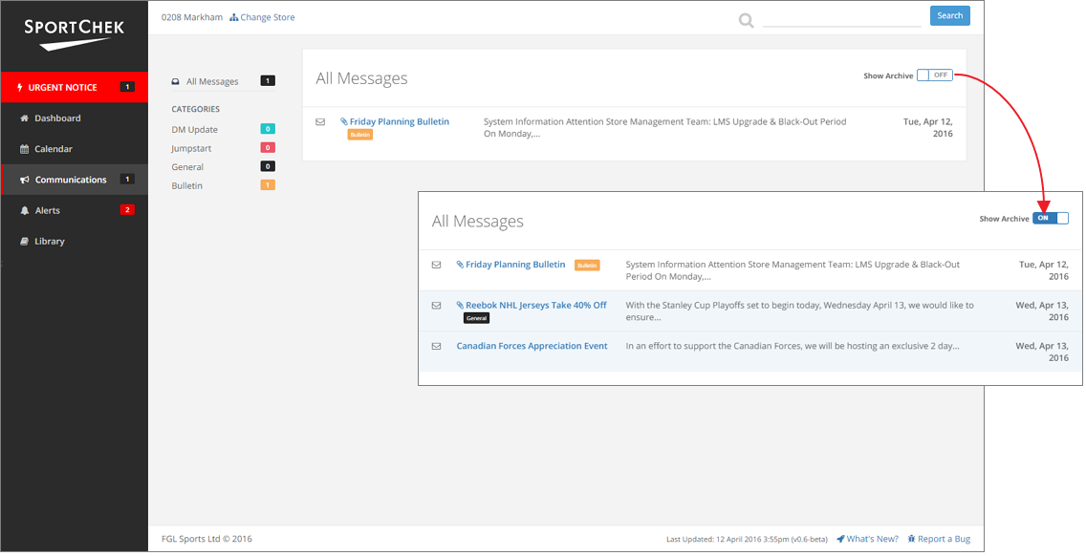

Ops Portal Overview - Single Communication

Single Communications have a Title, Date posted, a message body and, optionally, attachments. The attachments open (for PDFs and videos) or download (for spreadsheets) when clicked.

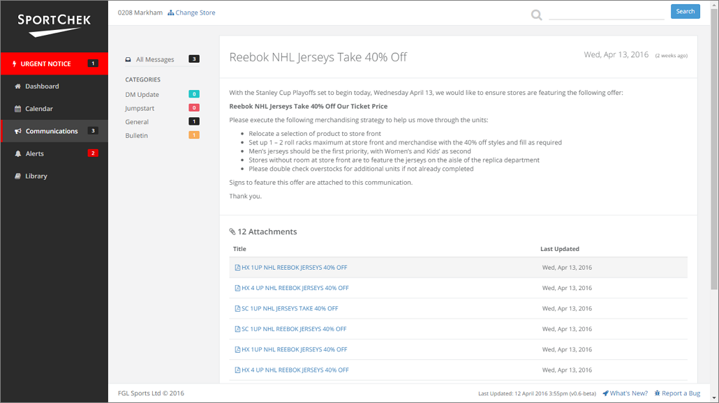

Ops Portal Overview - Alerts Listing

Since the site already knows which store you are from, you will only see alerts that affect your store. You can also see past alerts by clicking on the **Show Archive** toggle. Alerts open (for PDFs) or download (for spreadsheets) when clicked.

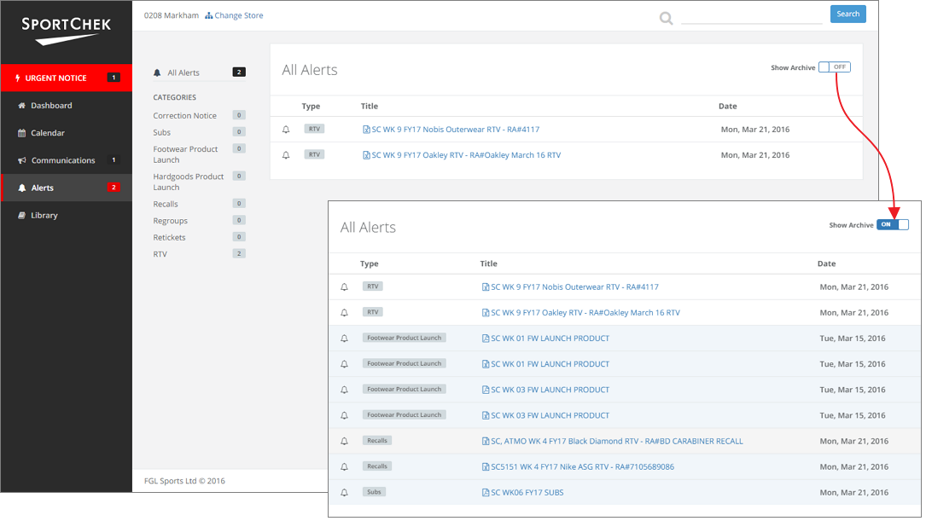

Ops Portal Overview - Library

The Library is where almost all of the documents live on the Ops Portal. You can browse the folder structures to find all the files on the site. The **Show Archive** toggle is also available when you are looking for older documents.

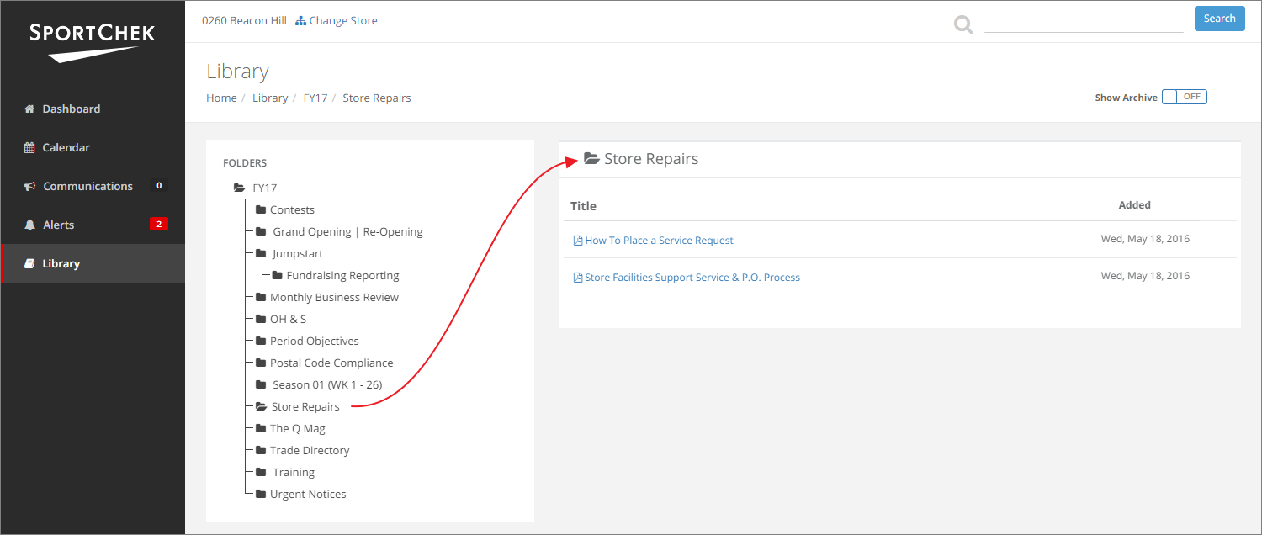

Ops Portal Overview - Search

When you use the Search, you will see matches for Documents, Alerts, Folders and Communications.

[ image pending - Search logic updates in Backlog ]

Ops Portal Overview - Features

Features, accessed from the Dashboard, are collections of documents and folders that are relevant to a particular event/program but might be scattered across different folders in the Library. Ad Execution, Jumpstart, Back to School, and Black Friday are examples of Features.

